**Case study: FeatureBase, Part 3: Exploring the trends with visualizations**

In previous courses, you learned about FeatureBase, an OLAP database company that solved a problem with their sales cycle. FeatureBase found that customers were leaving in the early stages of the sales cycle and not converting to paying customers. In this case study, you’ll learn about what came after the sales team made their findings: visual insights that helped FeatureBase solve their business problem.

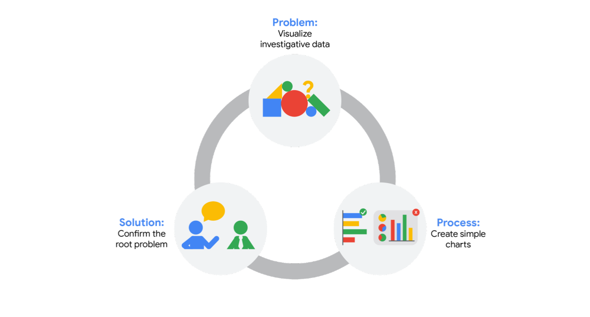

**Company background**

As a refresher, FeatureBase is an OLAP database company that enables businesses to gain insights from real-time analytics and AI. Their core technology, FeatureBase, is the first OLAP database built entirely on bitmaps that power real-time analytics and machine learning applications by simultaneously executing low latency, high throughput, and highly concurrent workloads. FeatureBase is sold to their clients, who become part of the sales cycle. This cycle includes the first point of contact with the potential customer to the moment they sign the purchasing contract and begin using FeatureBase.



**The challenge(s)**

As you learned in [the previous case study](https://www.coursera.org/learn/the-path-to-insights-data-models-and-pipelines/supplement/kq602/case-study-featurebase-part-two-alternative-solutions-to-pipeline-systems), the FeatureBase sales team realized that they didn’t have the data they needed to find when customers were falling off. To fix this, they recreated their original sales funnel with new attributes that helped track customers at every stage of the sales cycle.

Their next challenge was deciding the best way to visualize the problem for the sales team.

**The approach**

FeatureBase selected an informal series of simple charts rather than a dashboard to help make fast decisions. This allowed the sales team to find the most difficult stage of the sales cycle in a matter of minutes, rather than requiring at least a week of dashboard creation. While many complex business questions are best answered with a carefully-crafted dashboard, this problem required a simple visual solution.

FeatureBase’s sales team used DataStudio to create a simple line graph that tracked the conversion rate from each stage to the next. The first data point on the left would represent 100% of the potential customers that began the sales cycle. At each following stage, represented on the X axis, the data point would represent how many potential customers converted to the next step of the sales cycle.

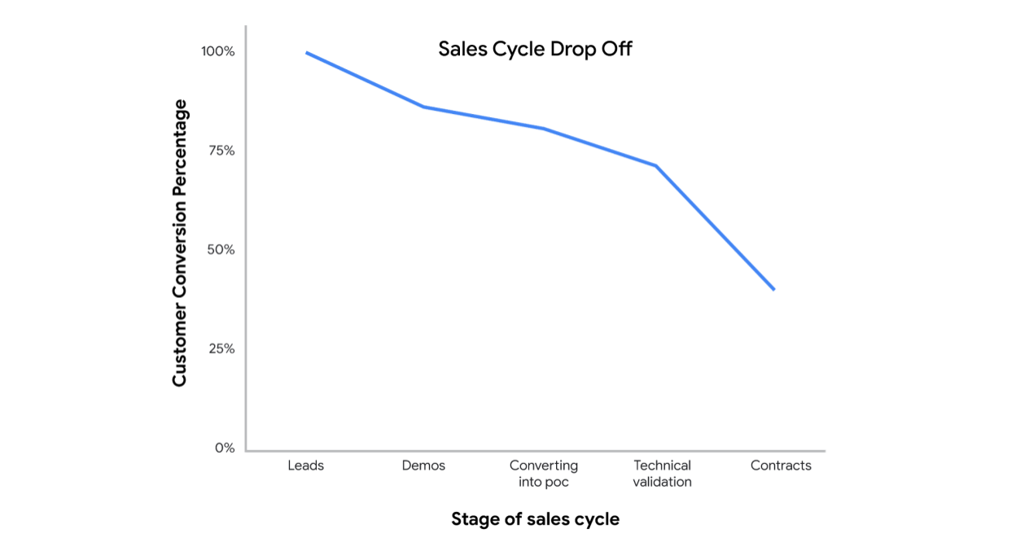

With this, they confirmed that a significant amount of customers dropped off at the technical validation stage. The line graph they made had a significant drop between the technical validation stage and the contract stage – meaning that a large portion of users backed out of the sales process because they didn’t complete the technical validation process.

This stage is the point at which FeatureBase would be implemented in the customer’s data environment to determine if it was actually functional for them. At this stage, the sales team could showcase FeatureBase’s utility and provide proof that it would be a workable solution for their customer.

With this insight, they could infer that either the technical validation stage had a fundamental problem, or the clients were having trouble understanding the highly-technical aspects of FeatureBase.

**The results**

Once the sales team knew that technical validation was the likely stopping point for their customers, they wondered if only certain types of potential customers were experiencing difficulty. They created a bar chart that represented different channels, or types of clients.

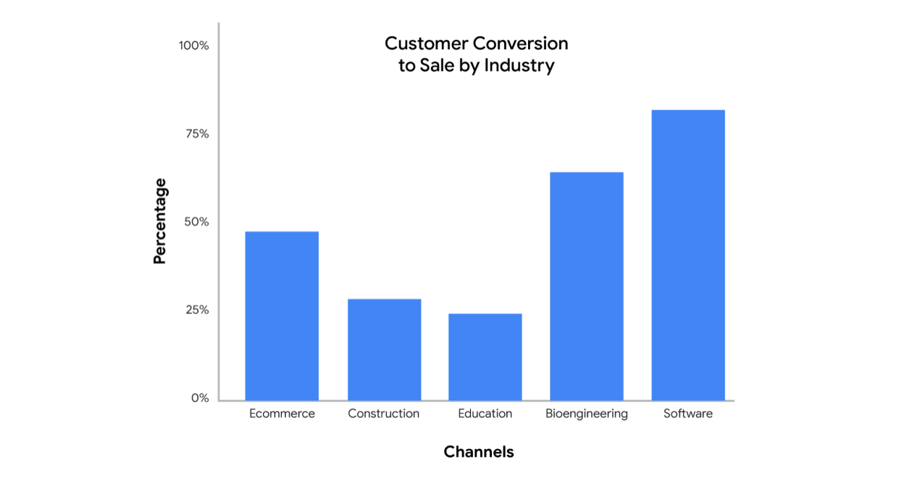

With this bar chart, FeatureBase’s team found that companies or points of contact who had non-technical backgrounds were the ones that were less likely to proceed to the contract stage. Then the sales team made a pie chart to confirm their suspicions. This pie chart offered evidence that an evaluator with a non-technical background was less likely to sign contracts.

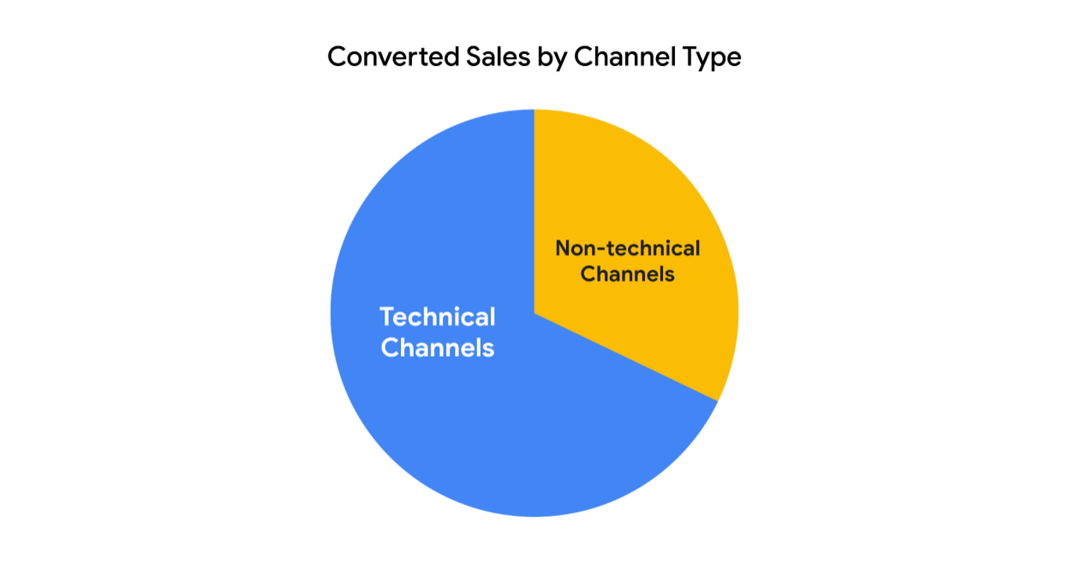

**Conclusion**

By visualizing the data, FeatureBase’s sales team and leadership found that their technical validation stage might be too confusing for non-technical clients and that selling to them is less likely to be successful. Using this insight, the team pivoted to focus on turning users into “champions” that would then advocate for the product and “sell” it to their business unit leaders. These champions could help their teams understand how to use FeatureBase and answer questions that might otherwise discourage clients. What started as a question to be answered eventually led to a business strategy change where the BI professional played a critical role in helping FeatureBase make a data-driven decision. The sales team was able to answer this question with just a few charts. In this situation, a huge dashboard would have taken too long to create. The team’s priority was finding the source of the drop off as quickly as possible, so a simple solution was most effective.

In your role as a BI professional, you may find that the traditional solution isn’t the best one for every situation. It’s your job to determine the best way forward by applying your BI knowledge and creative thinking to each of your projects.